# TaskerCLI

## Activity Diagrams

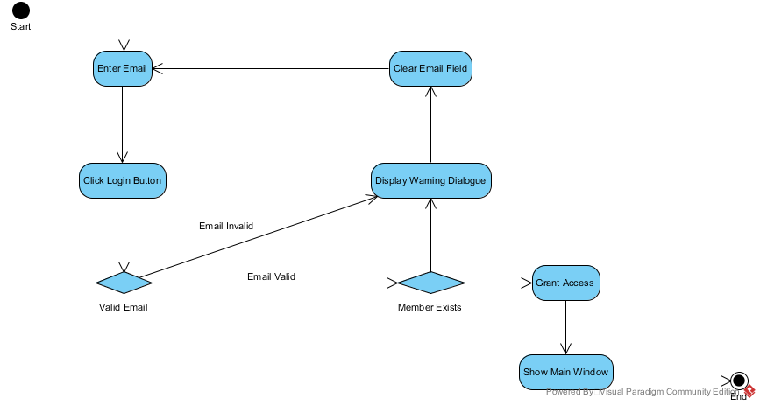

### Login

### Connecting to TaskerSRV

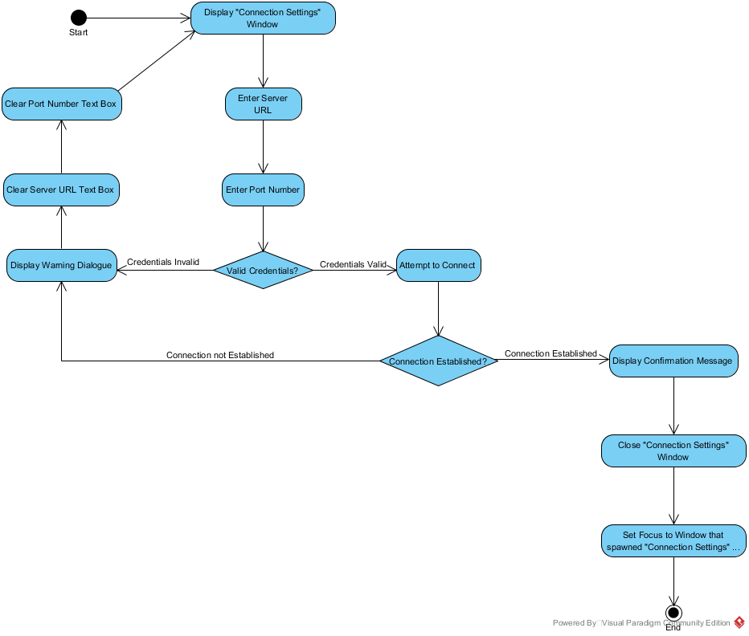

### Editing a task

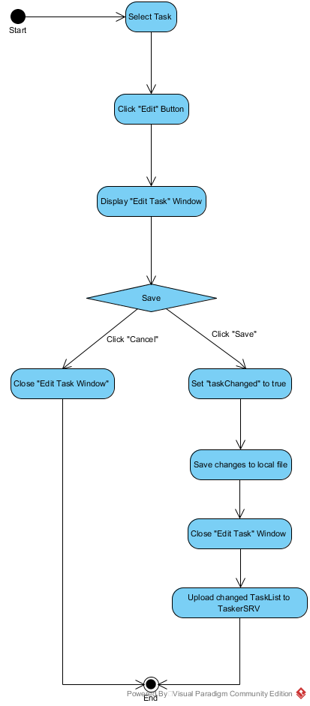

## Class diagram

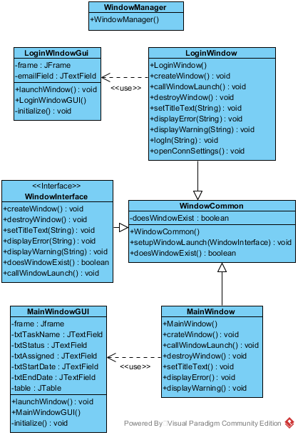

## Significant Data Structures

### Database class structure

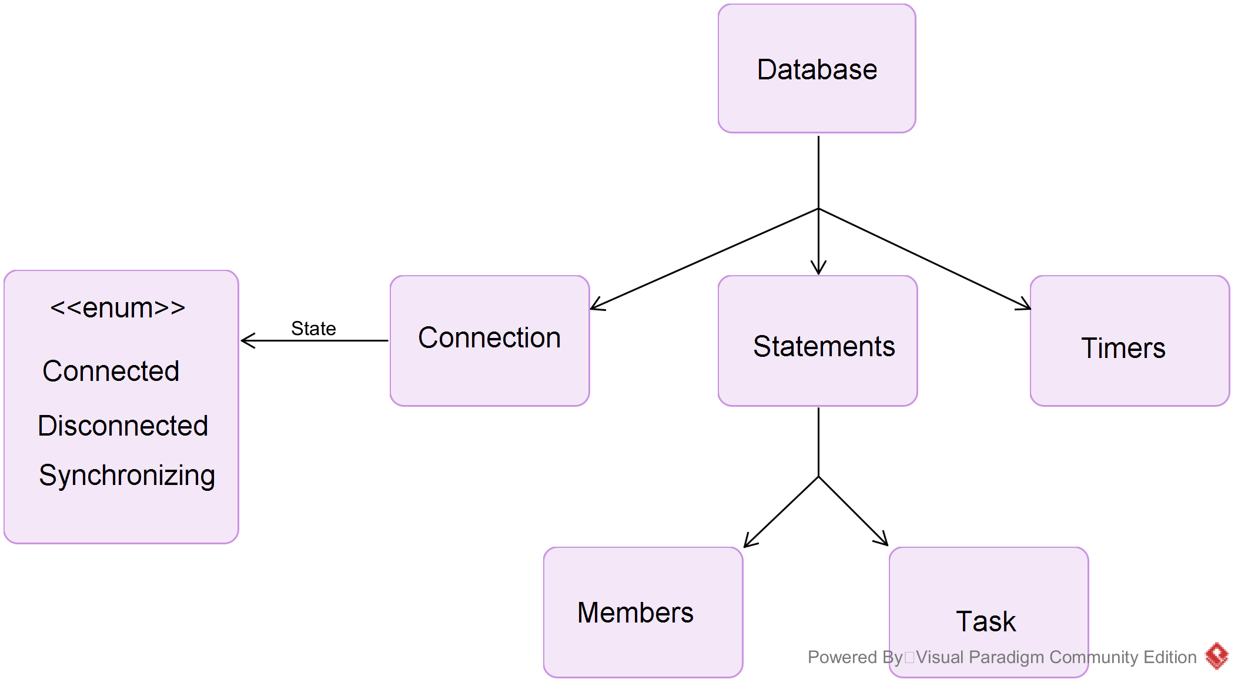

### Members and Tasks Structure

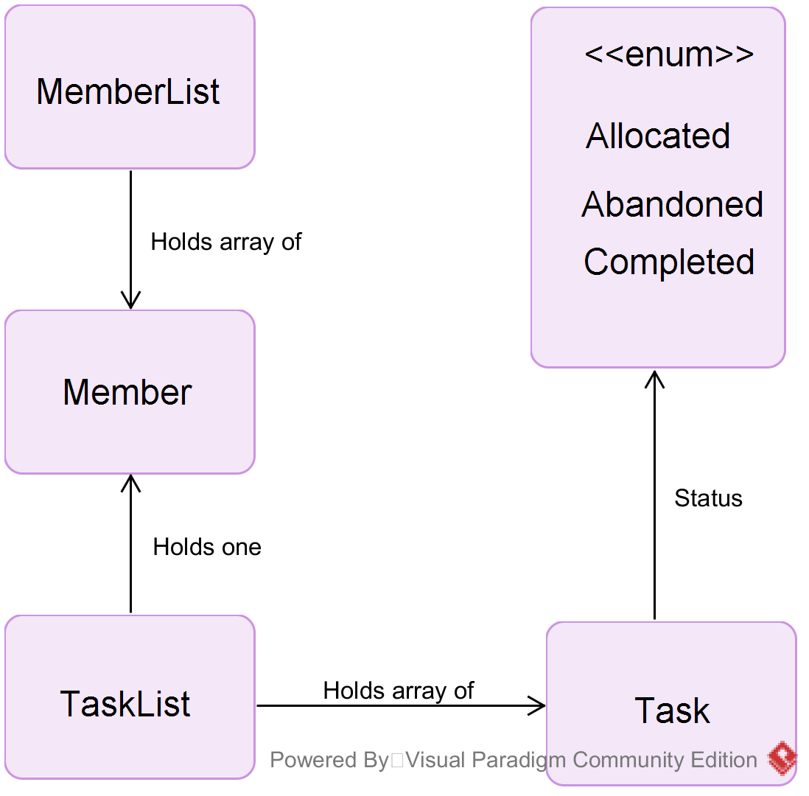

## Sequence Diagrams

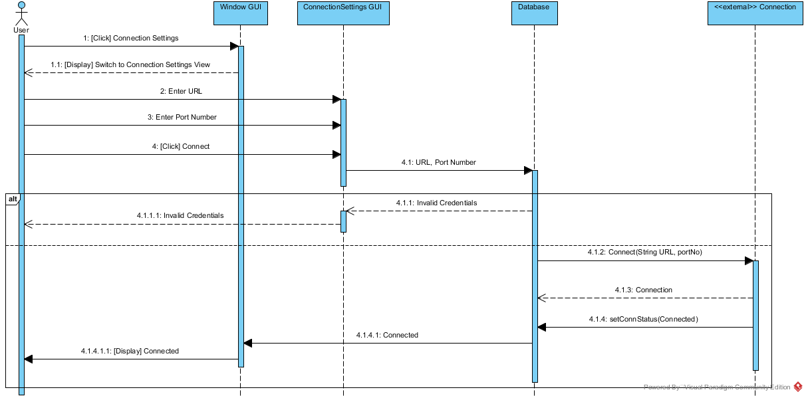

### Connecting to TaskerSRV

### Database Synchronisation

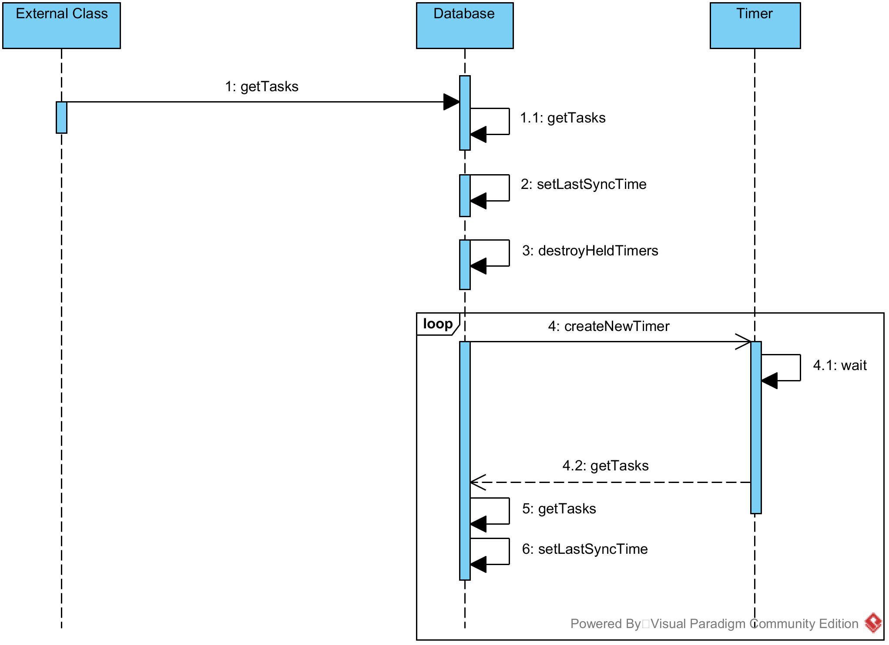

### User Login

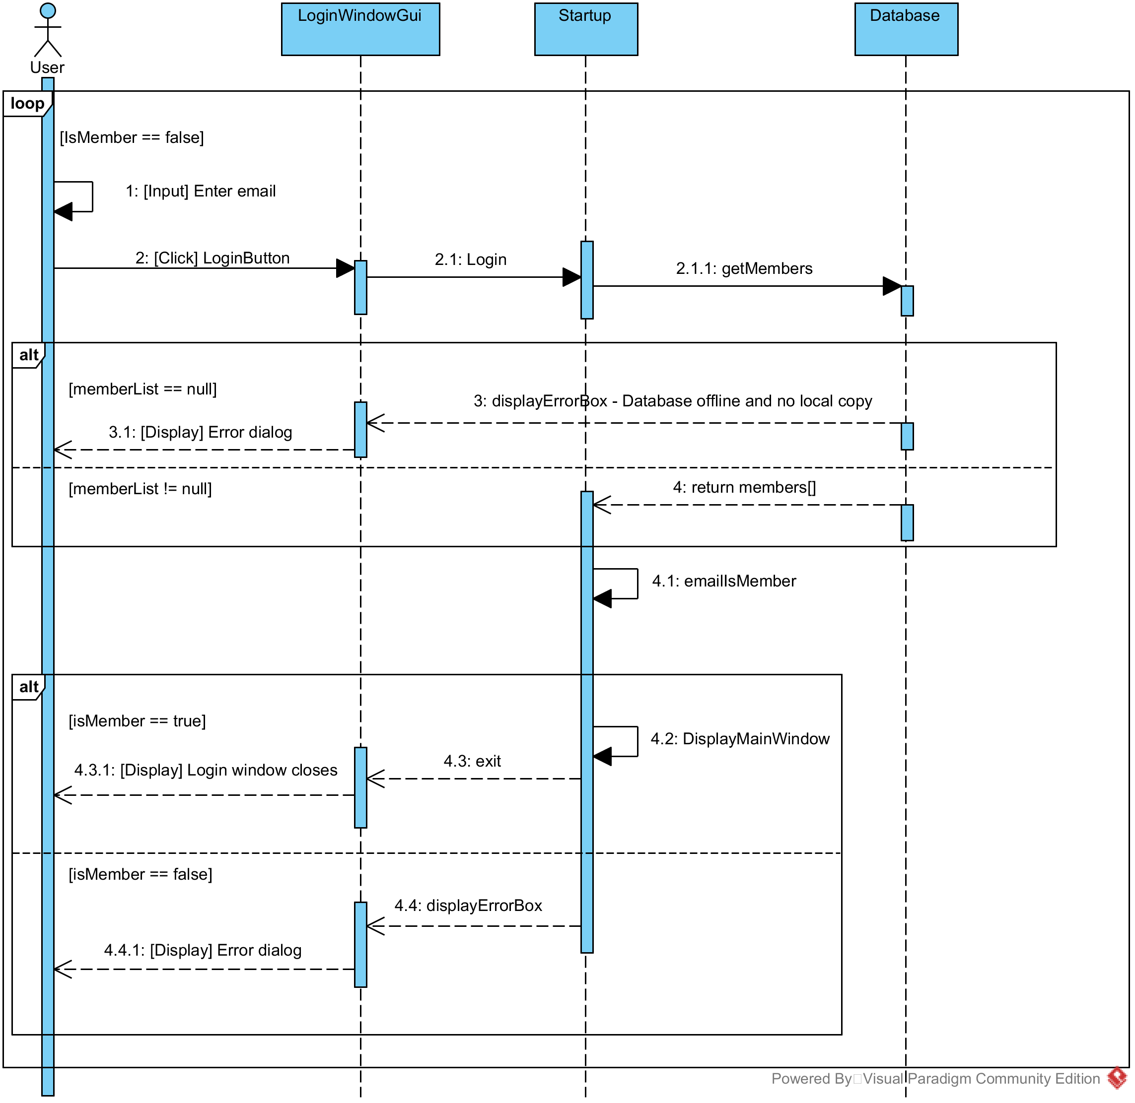

### Database Members Synchronisation

### 

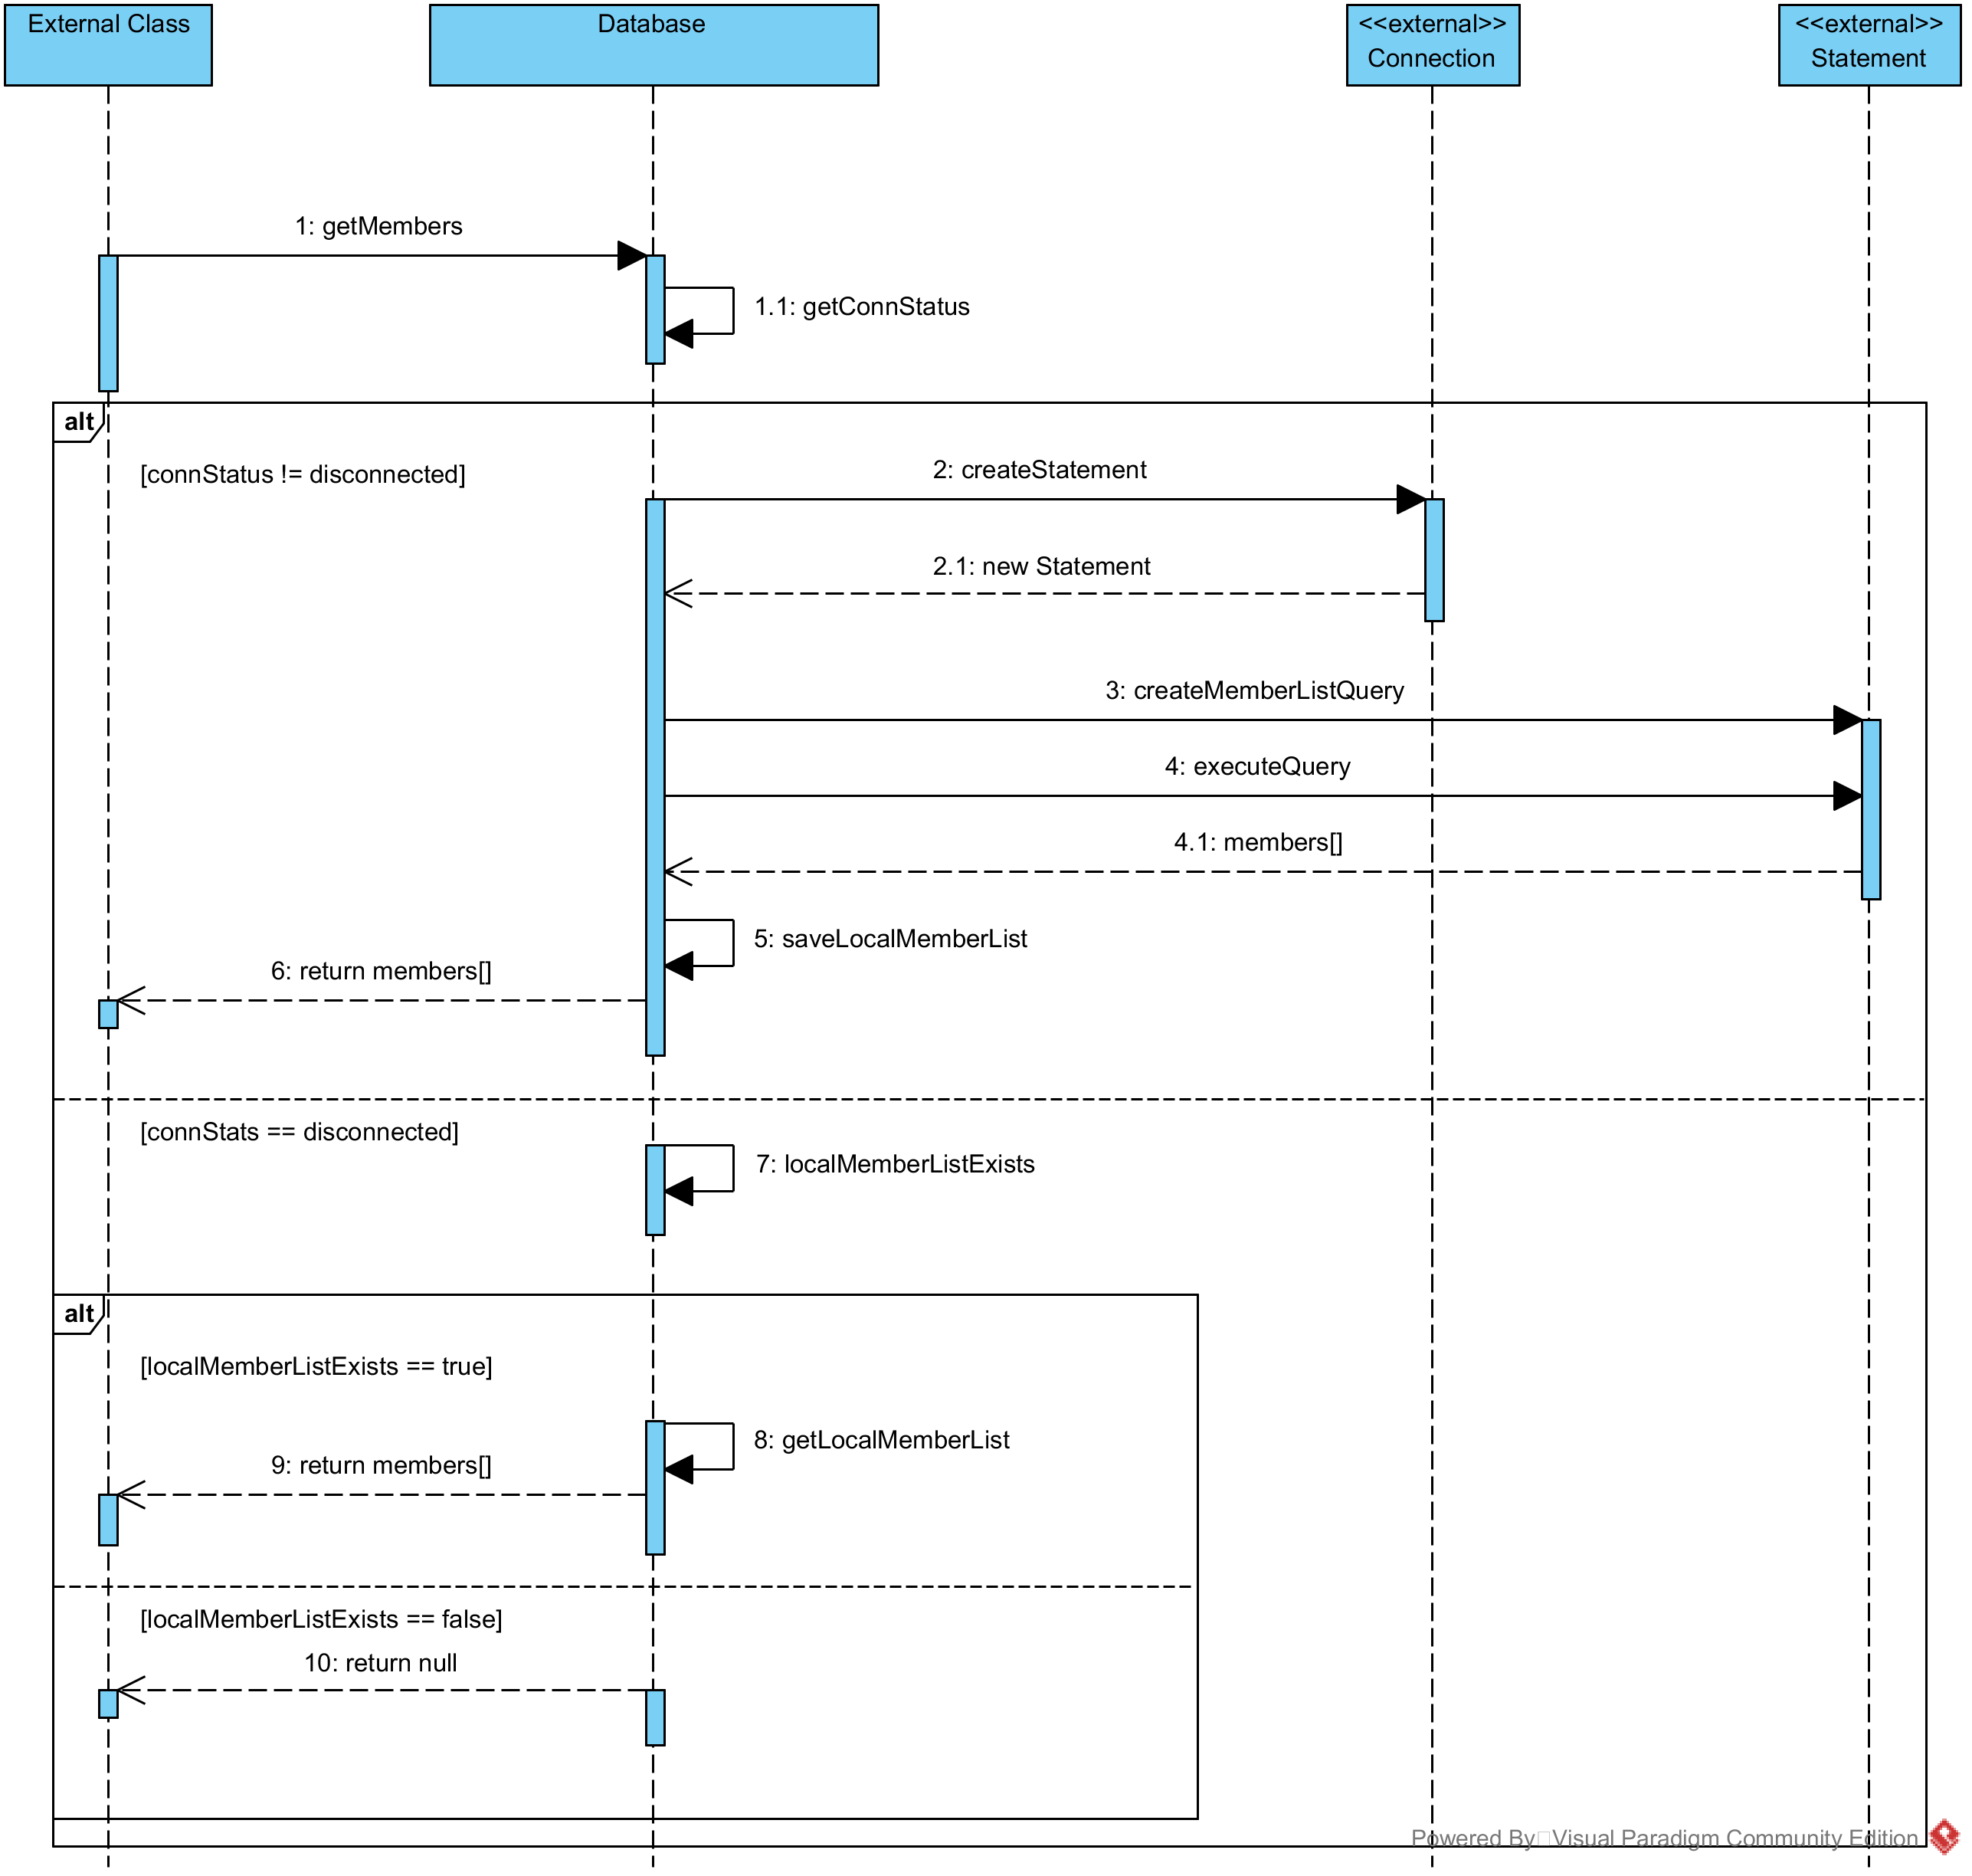

### Database Tasks Synchronisation

### 

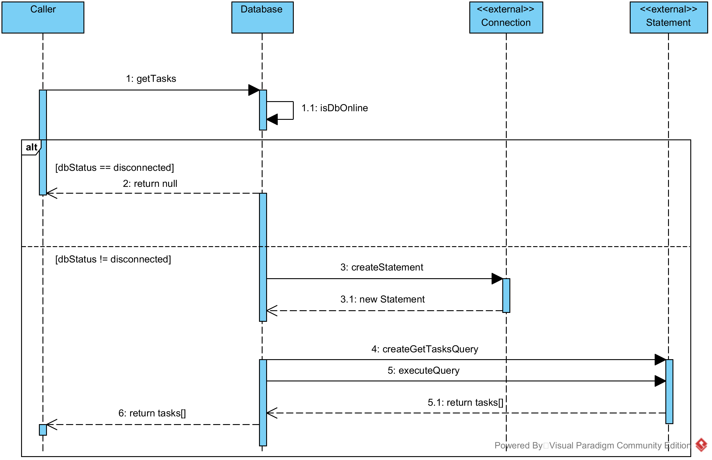

### Editing Tasks

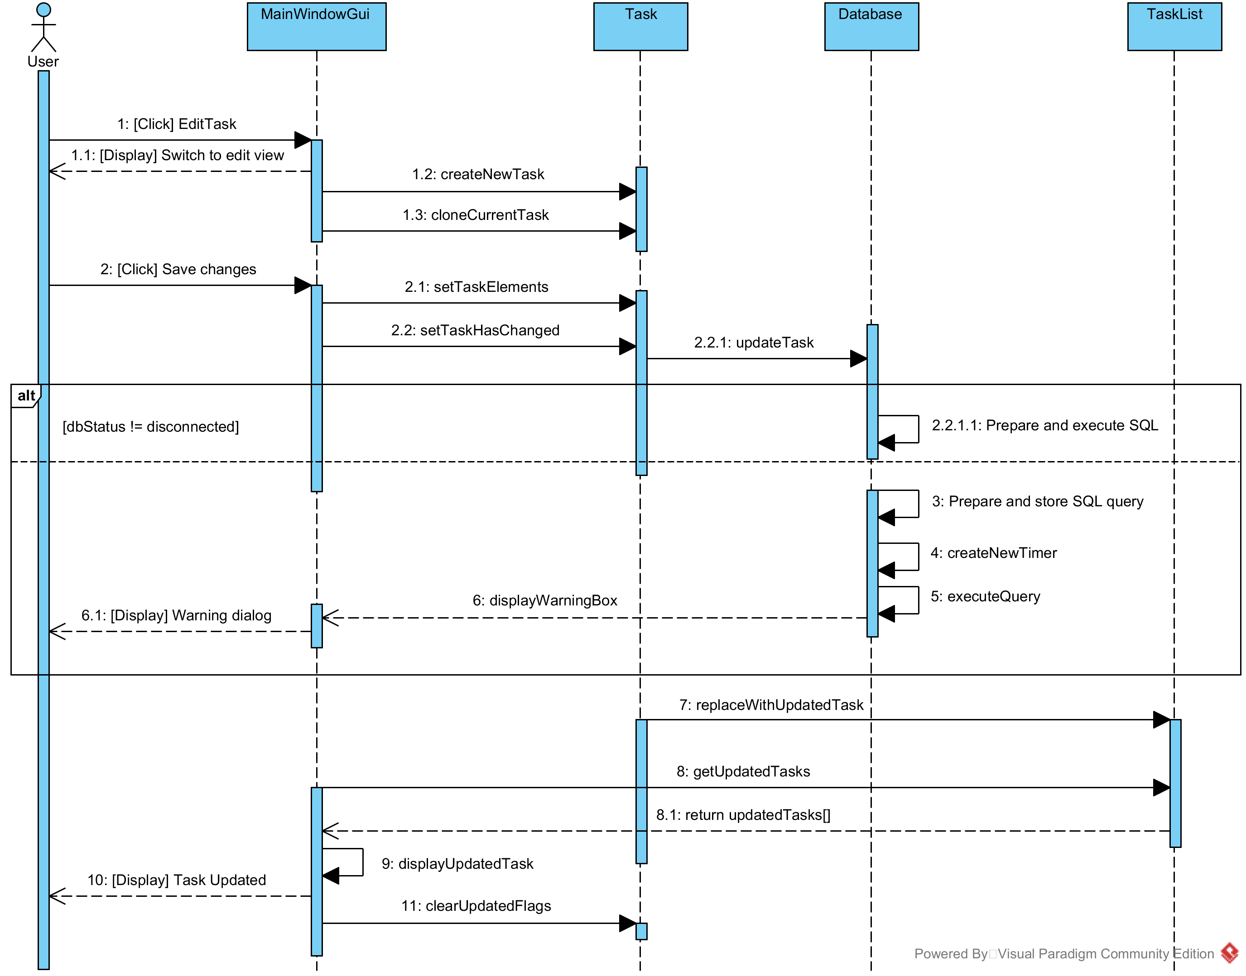

## DOCUMENT HISTORY

| *Version* | *CCF No.* | *Date* | *Changes made to document* | *Changed by* |
| --- | --- | --- | --- | --- |
| 1.0 | N/A | 12/09/08 | N/A - original version | CJP |
| 1.1 | N/A | 2010-10-12 | Updated to Office 2007; key field automation increased; paragraph styles updated | NWH |
| 1.2 | N/A | 2011-10-10 | Typos | NWH |
| 1.3 | N/A | 2015-10-16 | Update for Office 2013 | NWH |